SSH ISSUE IN WINDOWS
Ssh from linux machines to windows
- ++First of all we have to start the sshd services on our windows machine.
We can do this as:
Download the file freesshd.exe from the following path
http://www.freesshd.com/?ctt=download

- Install this software .
- Then a icon will be create on desktop with name freesshd
- Open this application
- It will show that freesshd service is running as:
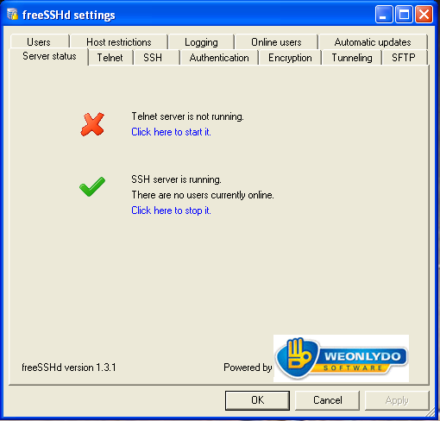

Then we can click on the user option. A dialogue box will appear as:
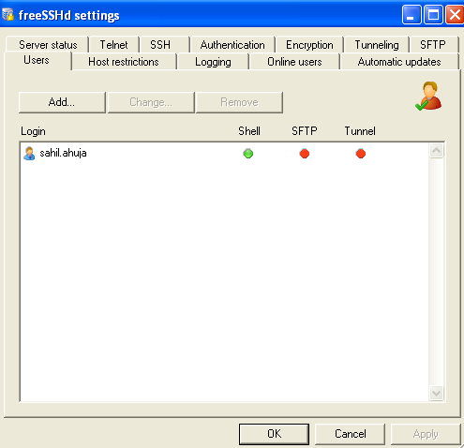

Click on add
And add the user that you want to ssh from the linux machine.
Now we can ssh from our linux machine to windows machine

Similarly to ssh from (10.100.211.63) linux server to windows server we need this sshd
Services to start..follow thw above procedure then

SSH KEY :
To generate key in 63 server
$ ssh-keygen -t rsa
Open $ /.ssh/rsa_pub
Take the public key of 63 from here
If we want to access 10.100.211.110 using 63 command prompt then public key of 63 should be added to the authorized key file of 110.
110’s authorized file is created sometimes when the server is new.
In our machine 110 the autorised file will be found in :C/documents/cmadmin/settings/
Then add the public key of 63 in 110 authorised file

switch user on 10.100.211.63
$ su - bharat
$ vi .ssh/id_rsa.pub
Chmod 770 cmadmin (cmadmin is user/110 server)

LINUX TO LINUX SSH COMMAND
SSH KEY :
To generate key in 63 server
$ ssh-keygen -t rsa
Open $ /.ssh/rsa_pub
Take the public key of 63 from here

If we want to access 10.100.211.61 using 63 command prompt then public key of 63 should be added to the authorized key file of 61.
61’s authorized file you have to make if it doesn’t exists.
In our machine 61 the autorised file will be found in cd /.ssh/
Then add the public key of 63 in 61 authorised file

Command: on 61
Go to tilt, then get out of root and switch user

$ cd .ssh/
Chmod 770 cmbuild (cmbuild is user of 61)
600 for authorised_file
700 for .ssh folder

.
(TRY DOWNWARD STEPS IF ABOVE PART DOESNT WORK)
After that, go to /etc/ssh/sshd./config then we have to comment something.

Then $ /etc/init.d/sshd

10.100.208.110 WINDOWS SERVER
COMPILATION OVERVIEW

1. Setting up the path of the environment.
2 configure the variables that we have passed from the 10.100.211.61 server.
3 if the build is RC then tag creation will take place and continue.
- Creation of various folders.(build area)
(log area)
(summary)
(build version)
If the build is RC build then created tag is checked out
In DEV BUILD case, the whole code is checked out from repository.
- Enter the folder where we have checked out the code and start compilation process.
- Create the release area and copy the binaries that we have after compilation.
- Then create the build information file and zip it up.
- Now if build is RC build then we will commit everything otherwise we will save it
Locally.
9. Sending mails and update database will take place.

